Junior Sailing Instructor Certification
All Junior Sailing Instructors are required to pass a Level 1 Certification Course approved by the U.S. Coast Guard. Certification is completed within a 4 day – 40 hour course and includes teaching from and using a safety boat; use of land and on-the-water drills; sports psychology and physiology; lesson planning; classroom teaching techniques for eye-hand coordination skills; risk management; safety considerations and rainy day activities.
Experience and expertise in sailing small boats is required as well as having a current NASBLA safe boating certification (boater’s license) and USCG approved CPR and First Aid Certification. Each instructor teaching a class on the water has their own radio and chase boat. The instructor to student ratio is kept to under 9 students per instructor; a smaller instructor to student ratio with the beginner sailors.

Instructor Biographies
HEATHER SWITLIK
Head Instructor - Heather is from Bay Head and grew up sailing in both the Bay Head and Mantoloking Jr. Sailing Programs. She grew up sailing Duck boats, Blue Jays and Club 420’s in program, and continued her sailing career on the University of Rhode Island’s Sailing team. Heather now resides in Island Heights, races E-Scows both on the bay and nationally. This will be Heather’s first year as Head Instructor at Pine Beach Yacht Club.

ALEXANDRA DEITZ
Opti Racing Instructor - Alexandra Deitz grew up in Point Pleasant, NJ and learned to sail at Manasquan River Yacht Club. She is a graduate of Fairfield University and will be starting law school in the fall. Alex has been coaching sailors for five years, and has competed in regattas in Florida, Maryland, Connecticut, and eastern Canada, sailing 420s, FJs, and Vanguard 15s.


TIMMY SLICKERS
Opti Blue Instructor - Tim grew up sailing an Opti and a Laser at Ocean Gate Yacht Club. He currently lives in Pine Beach, is a 2009 graduate from Toms River South High School and will be attending Rowan University in the fall. Tim has been instructing our Opti sailors for the past 2 years.
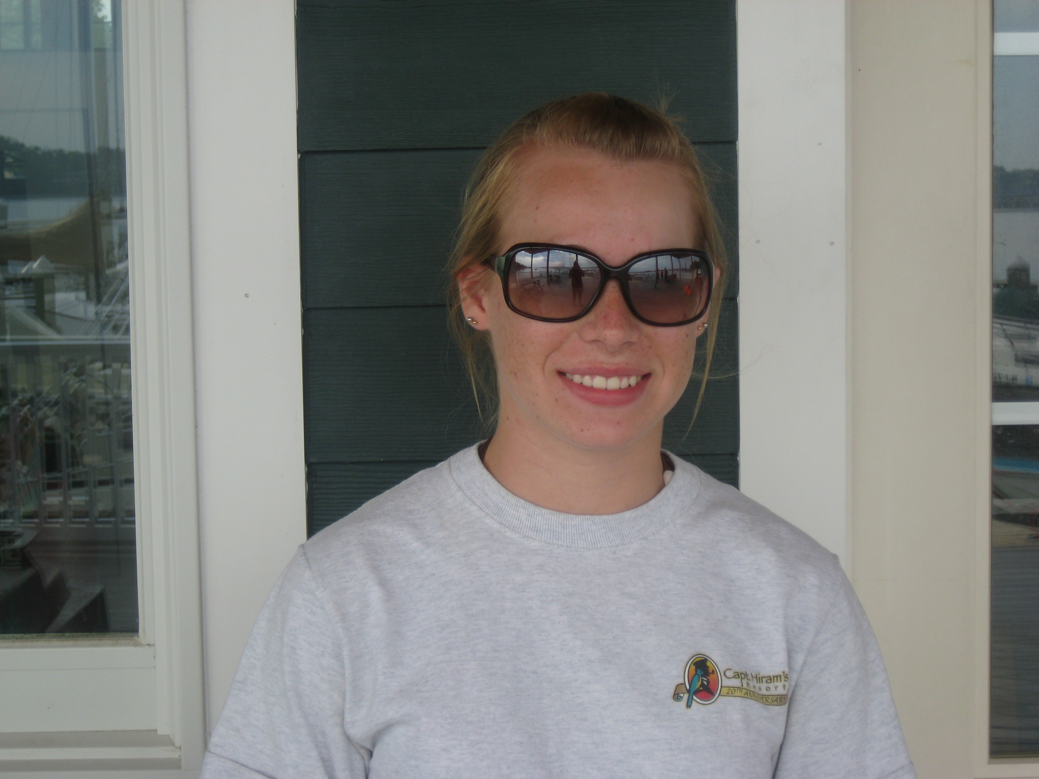
KATIE WALLING
Opti White instructor - Katie lives in Pine Beach and will be a freshman at Stevens Institute of Technology this fall. Growing up, Katie sailed Pram and Optis at BYC then sailed for PBYC for 5 years. This will be Katie’s 3rd summer working at Pine Beach Yacht Club.

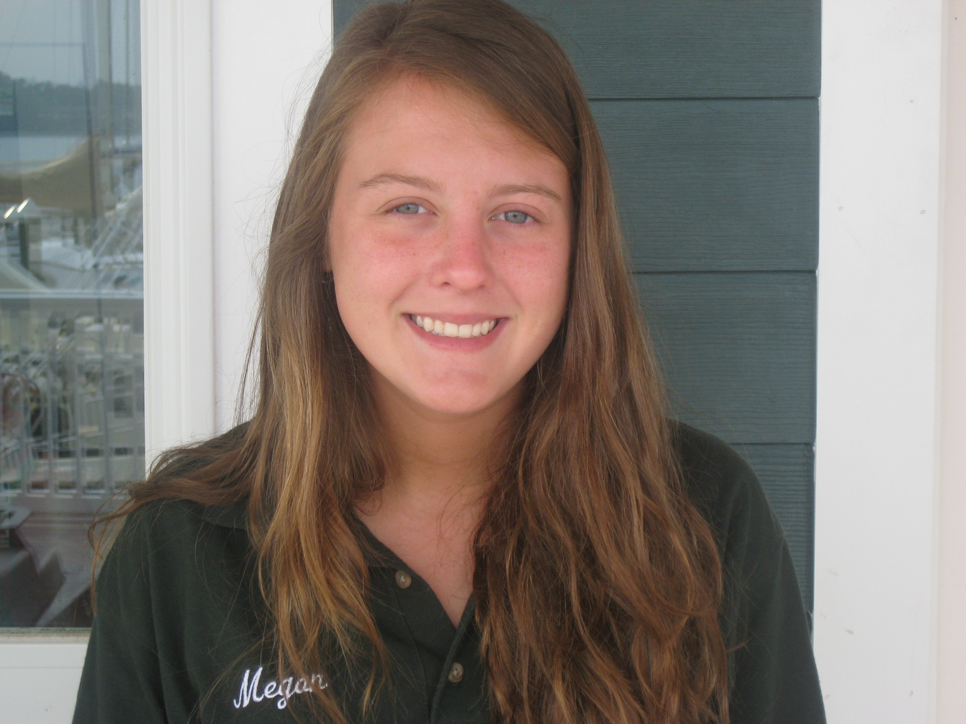
MEGAN BRIGHT
Opti Green Instructor - Megan, a resident and former sailor of Pine Beach, is a second year instructor. Megan grew up sailing Optis and Sunfish. She will be a senior at Toms River South High School in the fall.

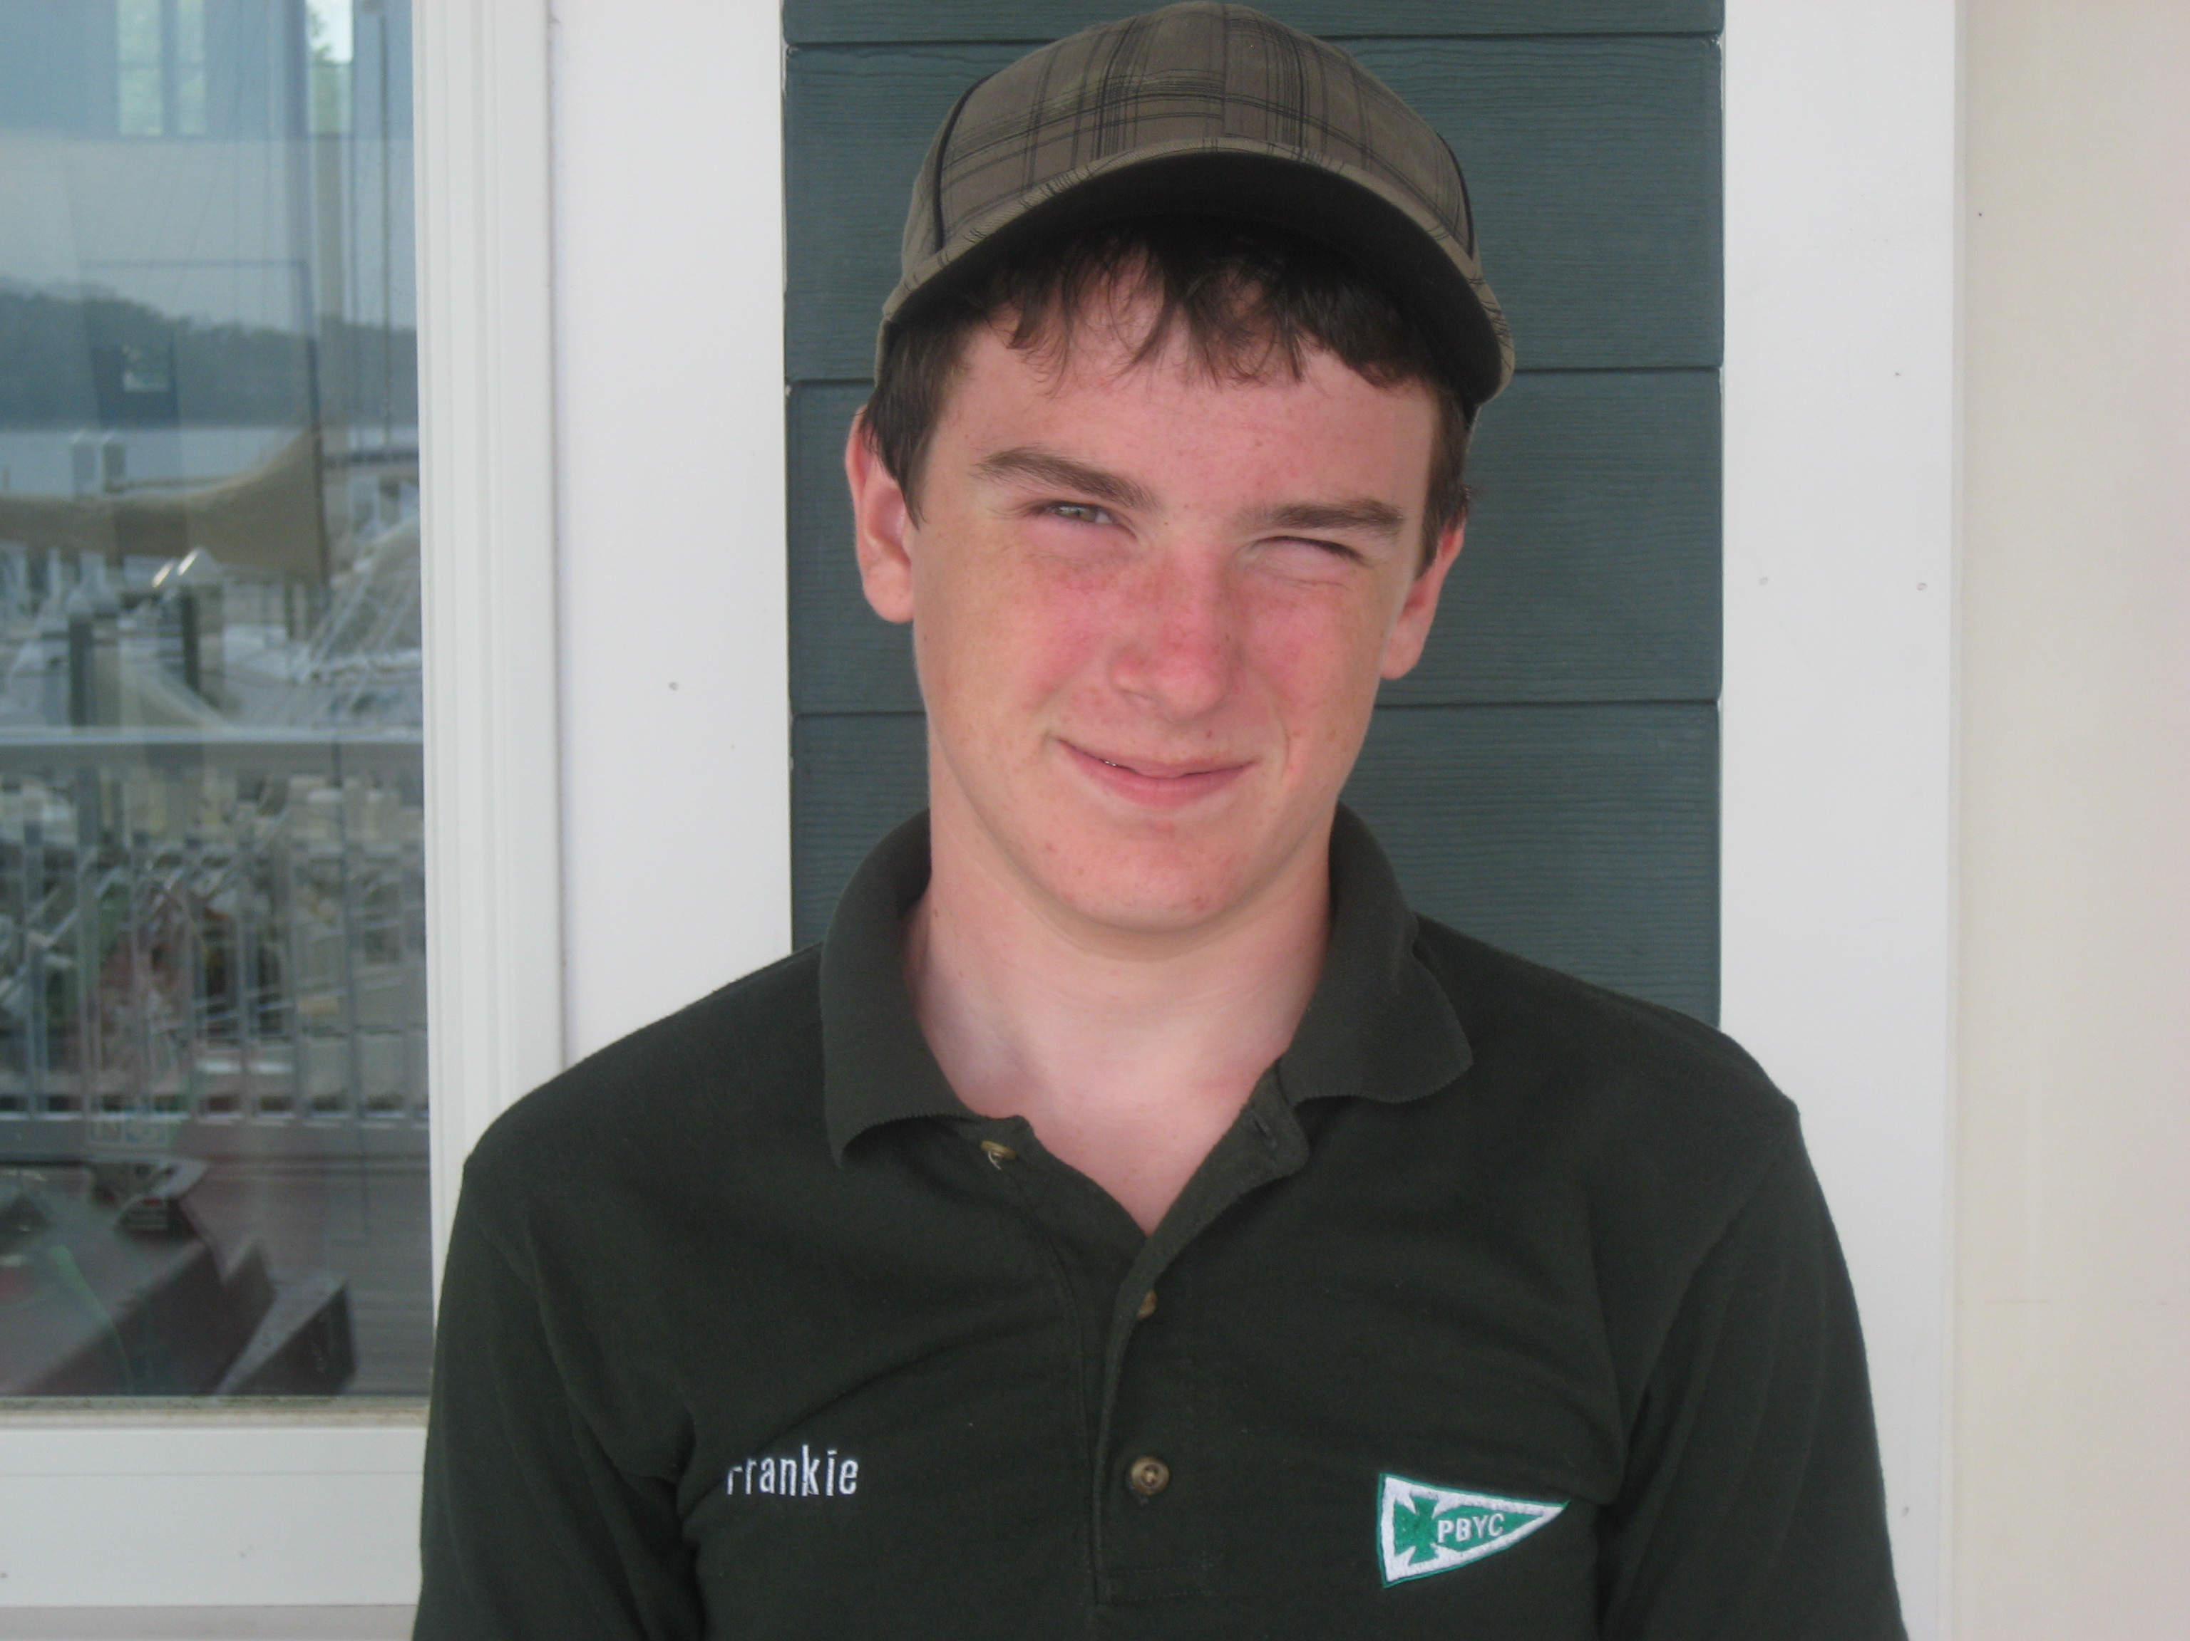
FRANKIE WESTON
Sunfish Instructor - Frankie is currently attending HS South, class of 2010. He is a member of the high school spring and fall Varsity Sailing Team. As a Pine Beach junior sailor, he won the Sportsmanship Award in 2005, and Most Improved Overall in 2006, among others. He has been sailing at PBYC for the past six summers and is experienced with the optimist, sunfish, 420, FJ and Flying Scot boats.

